**Custom hooks!!!**

React has some built-in hooks, such as the **useState** hook, or the **useRef** hook, which you learned about earlier. However, as a React developer, you can write your own hooks. So, why would you want to write a custom hook?

In essence, hooks give you a repeatable, streamlined way to deal with specific requirements in your React apps. For example, the **useState** hook gives us a reliable way to deal with state updates in React components.

A custom hook is simply a way to extract a piece of functionality that you can use again and again. Put differently, you can code a custom hook when you want to avoid duplication or when you do not want to build a piece of functionality from scratch across multiple React projects. By coding a custom hook, you can create a reliable and streamlined way to reuse a piece of functionality in your React apps.

To understand how this works, let's explore how to build a custom hook. To put this in context, let's also code a very simple React app.

The entire React app is inside the App component below:

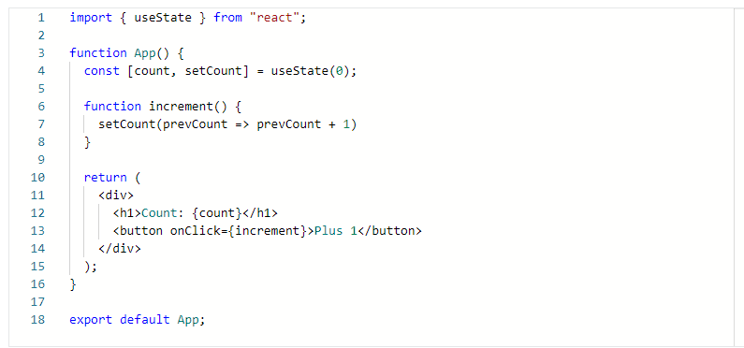

This is a simple app with an **h1** heading that shows the value of the count state variable and a button with an **onClick** event-handling attribute which, when triggered, invokes the **increment()** function.

The hook will be simple too. It will console log a variable's value whenever it gets updated.

Remember that the proper way to handle **console.log()** invocations is to use the **useEffect** hook.

So, this means that my custom hook will:

1. Need to use the **useEffect** hook and
2. Be a separate file that you'll then use in the App component.

### ****How to name a custom hook****

A custom hook needs to have a name that begins with use.

Because the hook in this example will be used to log values to the console, let’s name the hook **useConsoleLog**.

### ****Coding a custom hook****

Now's the time to explore how to code the custom hook?

First, you’ll add it as a separate file, which you can name **useConsoleLog.js**, and add it to the root of the **src** folder, in the same place where the App.js component is located.

Here's the code of the useConsoleLog.js file:

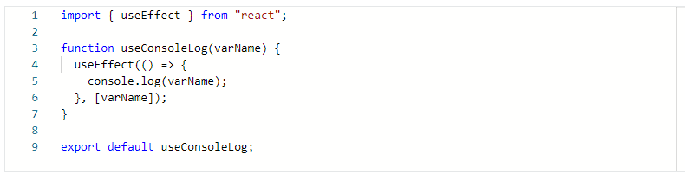

## ****Using a custom hook****

Now that the custom hook has been coded, you can use it in any component in your app.

Since the app in the example only has a single component, named App, you can use it to update this component.

The **useConsoleLog** hook can be imported as follows:

**import useConsoleLog from "./useConsoleLog";**

And then, to use it, under the state-setting code, I'll just add the following line of code:

**useConsoleLog(count);**

Here's the completed code of the App.js file:

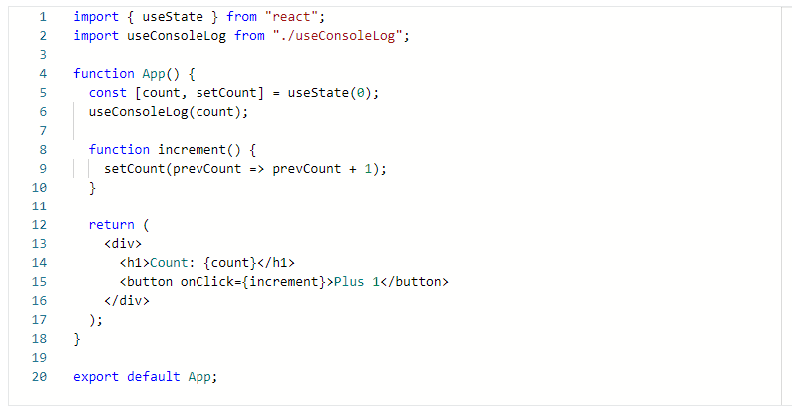

This update confirms the statement made at the beginning of this reading, which is that custom hooks are a way to extract functionality that can then be reused throughout your React apps

**Conclusion**

You have learned how to name, build and use custom hooks in React.